This proposal outlines the costs of deploying iobeam wireless broadband internet service at the Market Village in the city of Smyrna. Below, this location is referred to as the iobeam venue.

We recommend three distinct phases of deployment, allowing service availability to grow with user awareness. For each phase, iobeam will be responsible for installing the wireless equipment necessary to maintain the wireless broadband internet service at the venue. Once the installation is complete, each merchant at the venue will be given a free information packet containing brochures and signage describing the new service, its available features, and support contact information.

Based on performance measurements taken during a free site survey conducted in August, we propose the following hardware and service subscriptions:

Basic Insallation – Phase 1:

The basic installation provides wireless service in front of City Hall, extending 500’ in either direction along the circle, and extending through Market Village to Atlanta Rd. Limited service will be available within merchant storefronts and the outdoor areas in front of the Smyrna Community Center.

The goal of the basic installation is to provide wireless broadband service to the pedestrians and patrons of Market Village complex. Service availability near Atlanta Rd will be restricted to those areas with near line-of-site to City Hall.

Equipment:
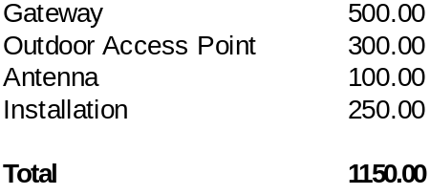

Subscription:
The iobeam service subscription for this venue allows unlimited wireless broadband internet access free of charge to all venue patrons. The cost for this venue subscription is $295 per month. If the service subscription is prepaid for 12 months, the price will be discounted to $200 per month.

Remote Installation – Phase 2:
This installation enhances wireless service availability in areas near Atlanta Rd. Service availability is also improved within merchant's stores along Village Green Circle. This phase requires the installation of remote relay equipment at or near the entrance to Market Village.

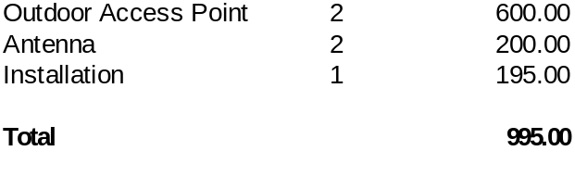Subscription:

The iobeam service subscription for Phase 2 entails an additional $50/mo maintenance fee for the remote relay equipment.

We look forward to providing Smyrna with iobeam’s premium wireless internet services.

For more information, feel free to contact us using the information below.

Jeff Blau
jblau@iobeam.com
678-268-4095 x 511

Joseph Dudar
jdudar@iobeam.com
678-268-4095 x 512

